Agility

Design Document

Scrum Master: Matthew Newman

Team Members: Matthew Greco, Christopher Myers, Stephen Canzanese, Jerico Alcon

**Details of Planned Pages**

Each page is features a navbar, each with an “Agility” button that takes you to the User Page. When necessary, the navbar will have a dropdown menu, with buttons to navigate to pages relevant to the current page. Additionally, each page has a “Log Out” button on the right hand side of the navbar.

**Sign-in Page**

This is the Sign-in Page for Agility. It includes text fields for the user to input the email address and password associated with their account. There is also a “Sign in” button which, if the email/password combination is correct for an account, navigates to the User Page. It also features a “Remember Me” button. There is also a “Click to Register!” button if the user does not yet have an account, which navigates to the Create Account Page.

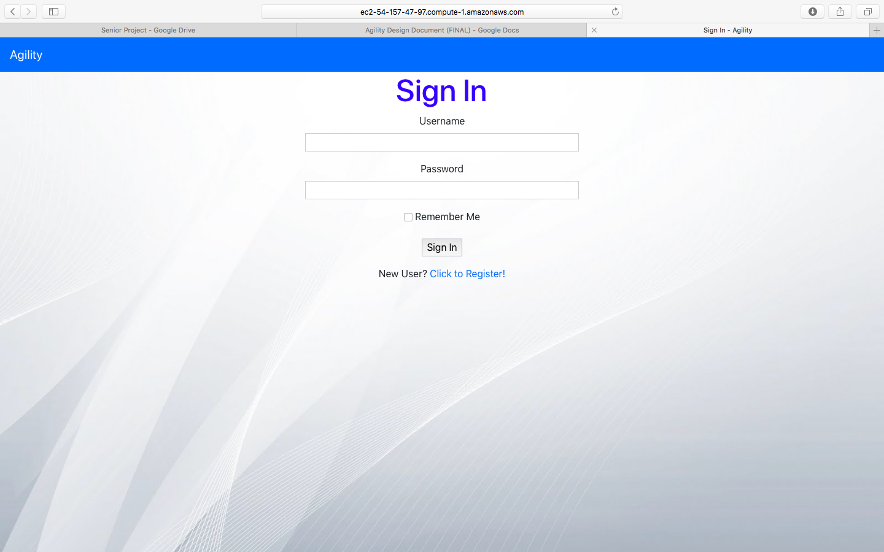

Website endpoints and correlating database tables used by Sign-in Page:

* User table

Buttons and corresponding tables:

* User table

**Account-Creation Page**

If the user selects the “Create Account” button on the sign-in page, then they are brought to the Account-Creation Page. Here, they enter information for their username, email, and password (which they must enter a second time to confirm). Upon filling out all the information, the user selects the “Register” button, which creates the account and navigates to their User Page.

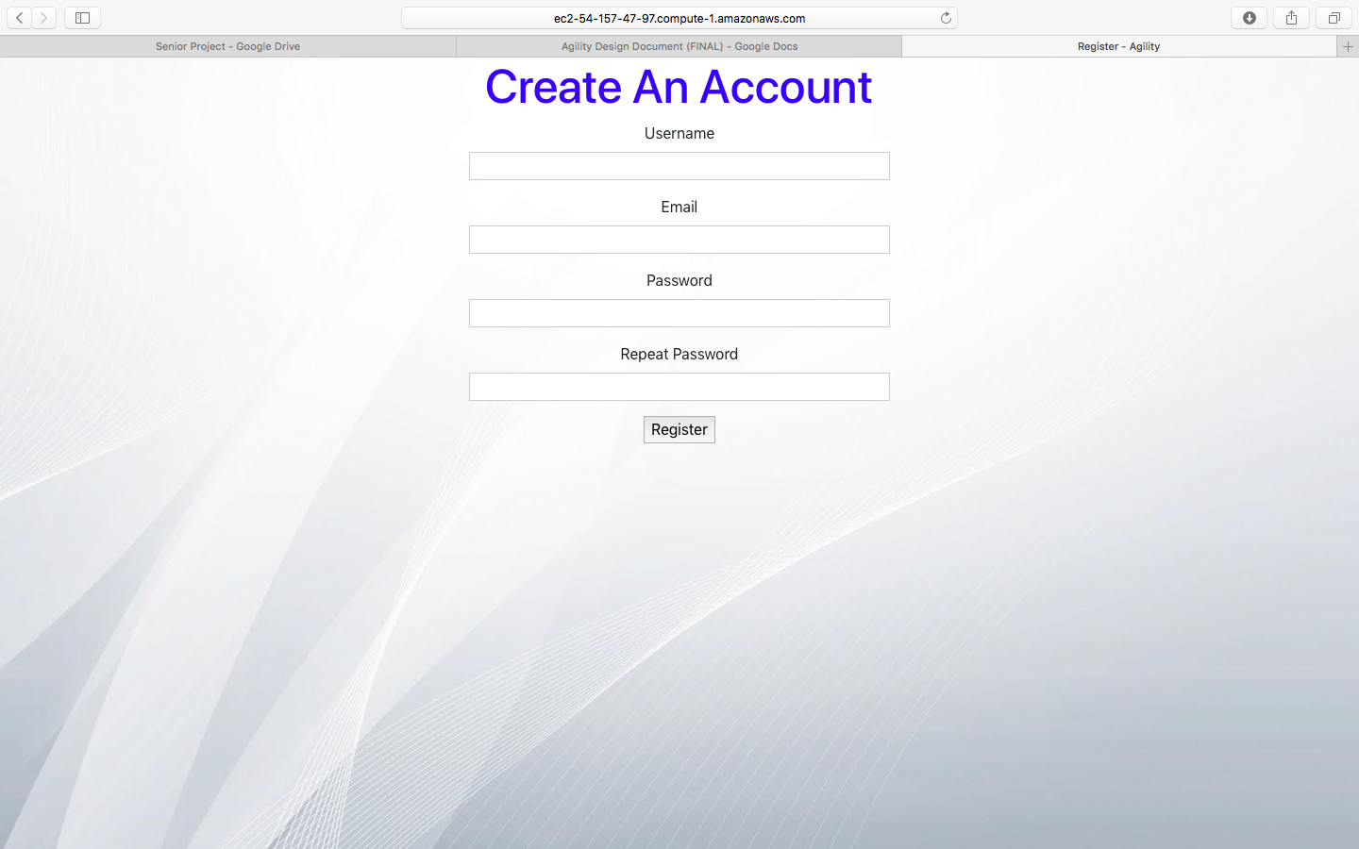

Website endpoints and correlating database tables used by Account-Creation Page:

* User table

Buttons and corresponding tables:

* User table

**User Page**

The User Page is the “home” page for the user. Here they can view the projects associated with their account, and are provided the ability to create a new project. If they select the button for a given project, then they are taken to the corresponding Project Page for that project. If the “New Project +” button is selected, then a new project is created.

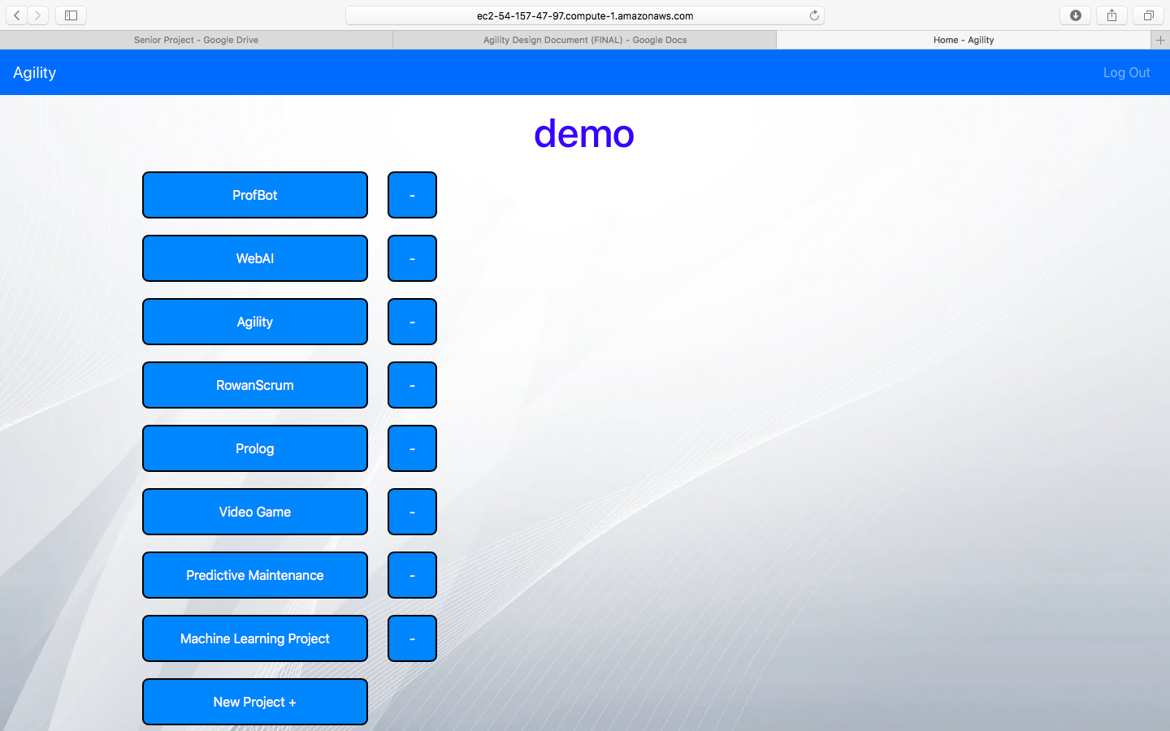

Website endpoints and correlating database tables used by User Page:

* User table
* Project table

Buttons and corresponding tables:

* all buttons: Project Table

**Project Page**

The project page serves as the “home” page for the project. The project name is displayed at the top, along with a button to view and edit the Definition of Done. It also provides the user with a “Sprint Management” button (which navigates to the Sprint Management Page), a “Current Sprint” button (which navigates to the page of the current sprint), a button that navigates to the project GitHub, a button that allows the user to navigate to the Edit GitHub Link Page, and a “Team Page” button, which navigates to the Team Page for the project. A burnup chart is also displayed, and is automatically generated based on the PBI data for the project. The burnup chart includes functionality to download the image, zoom in, pan, and resize.

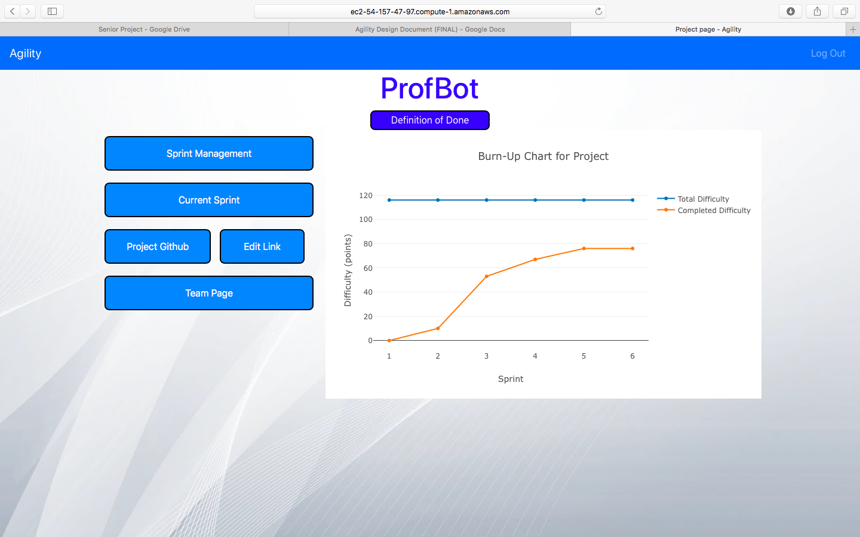

Website endpoints and correlating database tables used by Project Page:

* Project table
* Sprint table
* User_stories table
* Role table
* Team table

Buttons and corresponding tables:

* Sprint Management Button: Project table, Sprint table
* Current Sprint Button: Project table, Sprint table
* Github link Button: Project table
* Team Page Button: Project table, Team table
* Definition of Done: Project table

**Edit GitHub Link Page**

The Edit GitHub Link Page displays a header that says “Edit GitHub Link”, along with a text field for the user to edit a link to their project GitHub page. The link must be a GitHub link. Upon clicking the “Update GitHub Link” button, the new GitHub link is set and the user is navigated back to the Project Page.

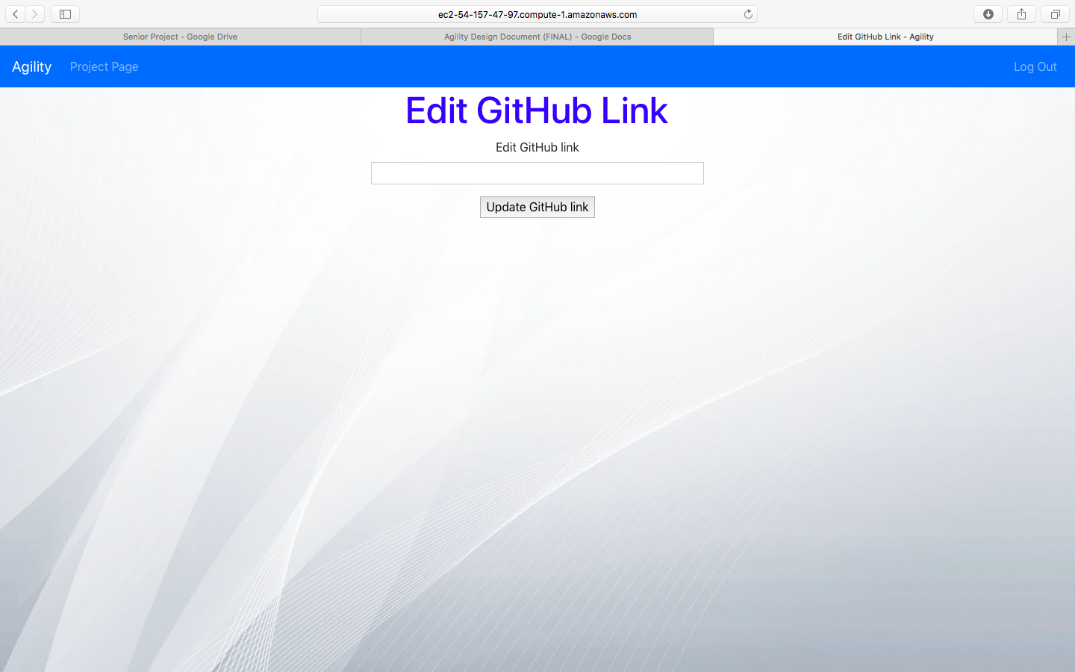

Website endpoints and correlating database tables used by Edit GitHub Link Page:

* Project table

Buttons and corresponding tables:

* Update Github link- project table

**Sprint Management Page**

The Sprint Management Page presents to the user buttons on the right-hand side of the page to navigate to each Sprint page, and also provides the ability for the user to create a new sprint. A scrollable version of the product backlog is presented on the left-hand side of the screen. Each PBI card shows the title and difficulty, and if the “View/Edit Card Details” button is clicked, then a modal pops up displaying further details of the PBI. There is also a “Create Product Backlog Item” button that navigates to the “Create User Story” page. If a button for a sprint is selected, then it navigates to the Sprint page for the corresponding sprint. If the “Create New Sprint” button is selected, then a new sprint is created.

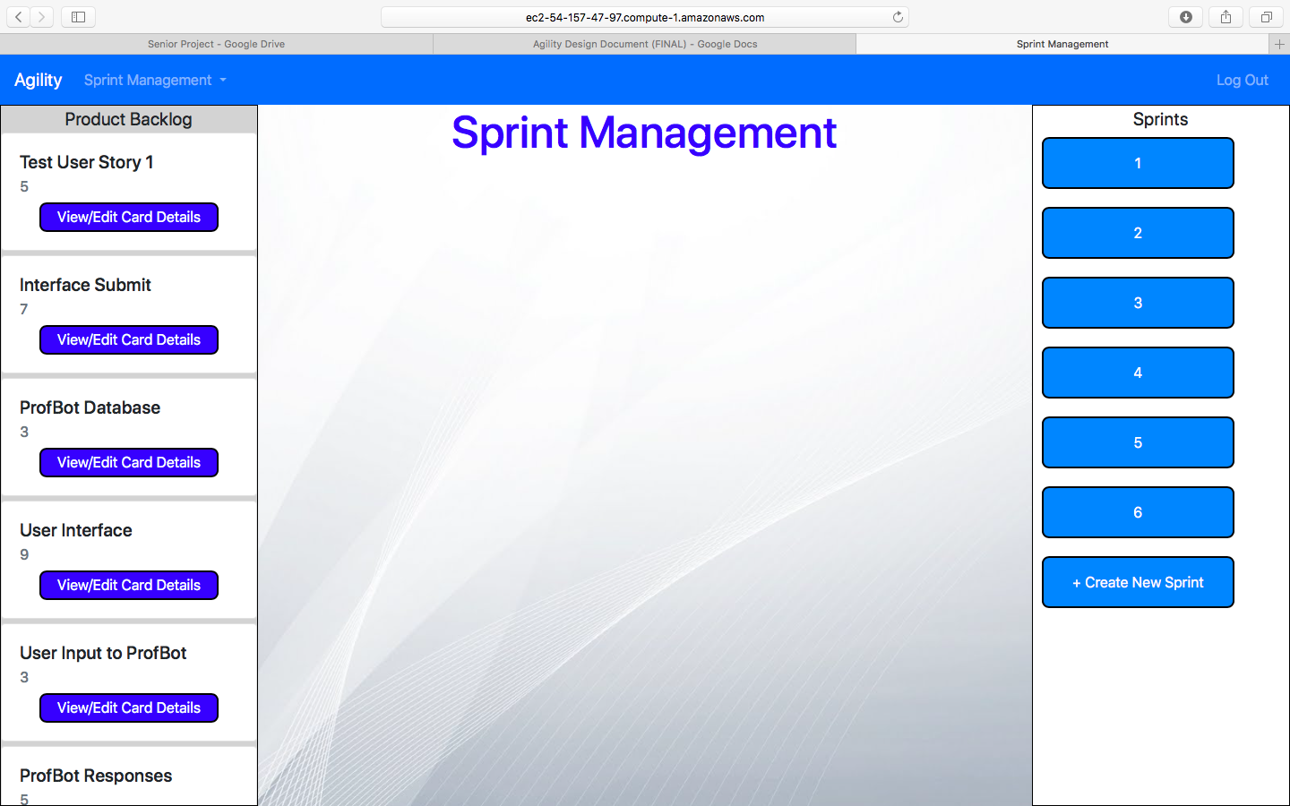

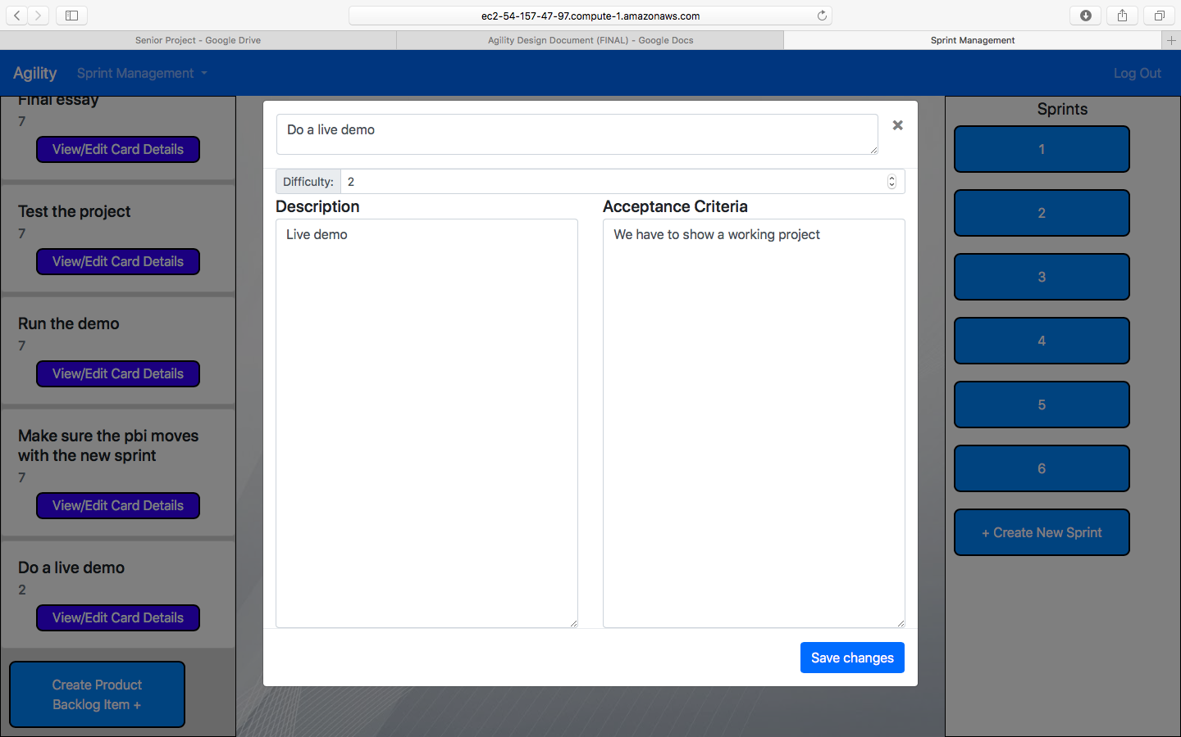

Website endpoints and correlating database tables used by Sprint Management Page:

* Project table
* Sprint table
* User_stories table
* Team table

Buttons and corresponding tables:

* Product Backlog Bar/Buttons: User table, Project table, Role table, User_Stories table
* Sprint Buttons: User_Stories table, Sprint table, Team table

**Create User Story Page**

The Create User Story Page features a header that says “Create User Story”, along with text fields for the user to enter the Card title, difficulty, description, and acceptance criteria. Upon clicking the “Submit” button, the new card is created, and the user is sent back to the Sprint Management Page.

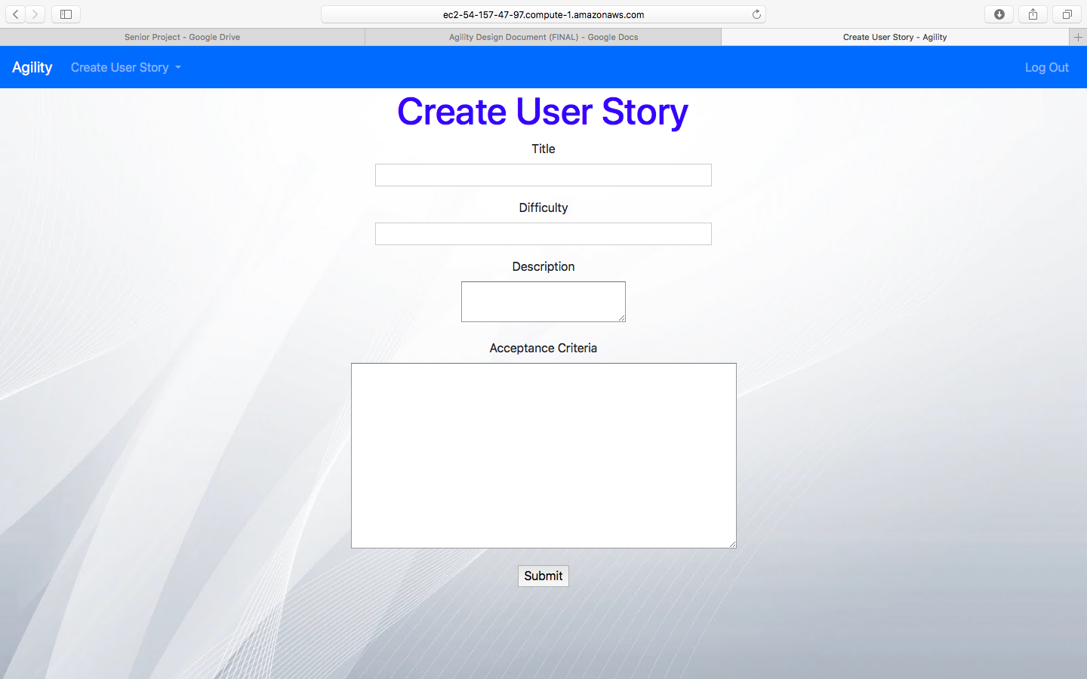

Website endpoints and correlating database tables used by Create User Story Page:

Buttons and corresponding tables:

**Create Sprint Page**

The Create Sprint Page features a header that says “Create Sprint”, along with text fields for the user to enter both the Start and End Dates. Upon clicking the “Submit” button, the new sprint is created and the user is navigated to the Sprint Page for the new sprint.

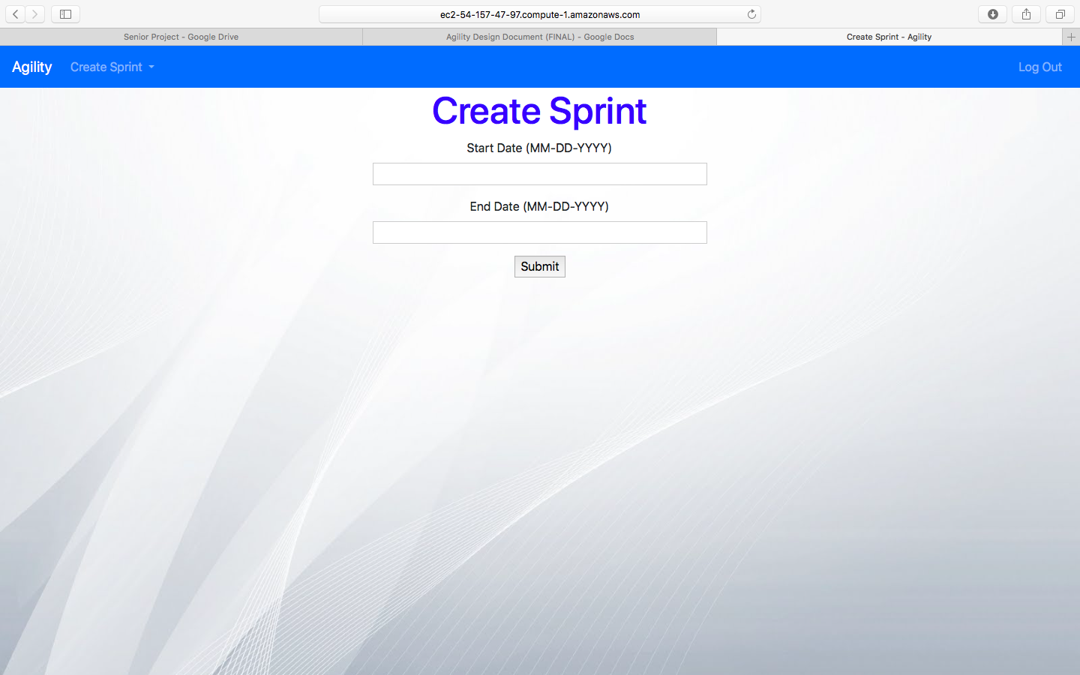

Website endpoints and correlating database tables used by Create Sprint Page:

* Sprint table
* Project table

Buttons and corresponding tables:

* Create Sprint Button: Sprint table, Project table

**Sprint Page**

The Sprint Page is the main page for a Sprint. It shows four scrollable lists of backlog items: Product Backlog, To-do, In Progress, and Done. The PBI cards in each list features “View/Edit Card Details button that navigates to the Card Page. A “Sprint Review” button is provided, and when selected, triggers a modal containing an editable text field. There is also a “Sprint Retrospective” button that triggers a separate modal similar to the “Sprint Review” button. A dropdown button is available for the user to easily switch between sprints.

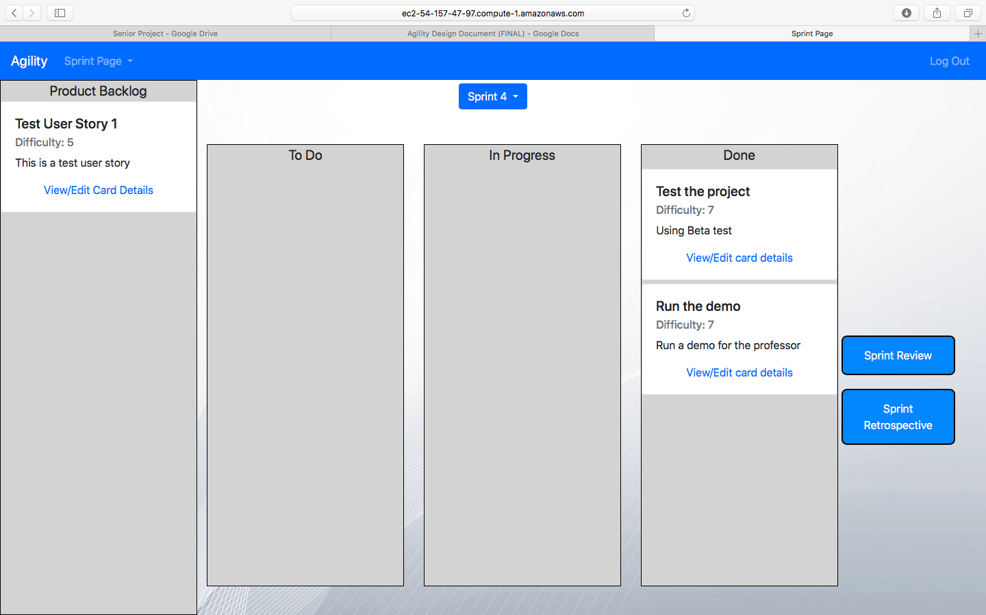

Website endpoints and correlating database tables used by Sprint Page:

* Project table
* Sprint table
* User_stories table

Buttons and corresponding tables:

* Sprint Bar: Sprint table
* Product Backlog Bar: Project table, User_Stories table
* Sprint Review Button: Sprint table, Project table
* Sprint Retro Button: Sprint table, Project table
* To do, In Progress, and Done bar: User_Stories table, Sprint table

**Card Page**

The Card Page features editable text fields where the user can view and edit information for the card. There are text fields for the card title, difficulty, description, and acceptance criteria. There are also buttons to submit the data and delete the card, along with a dropdown button to select which list to place the card in. Upon clicking the “Submit” or “Place In…” buttons, the user is navigated back to the Sprint Page.

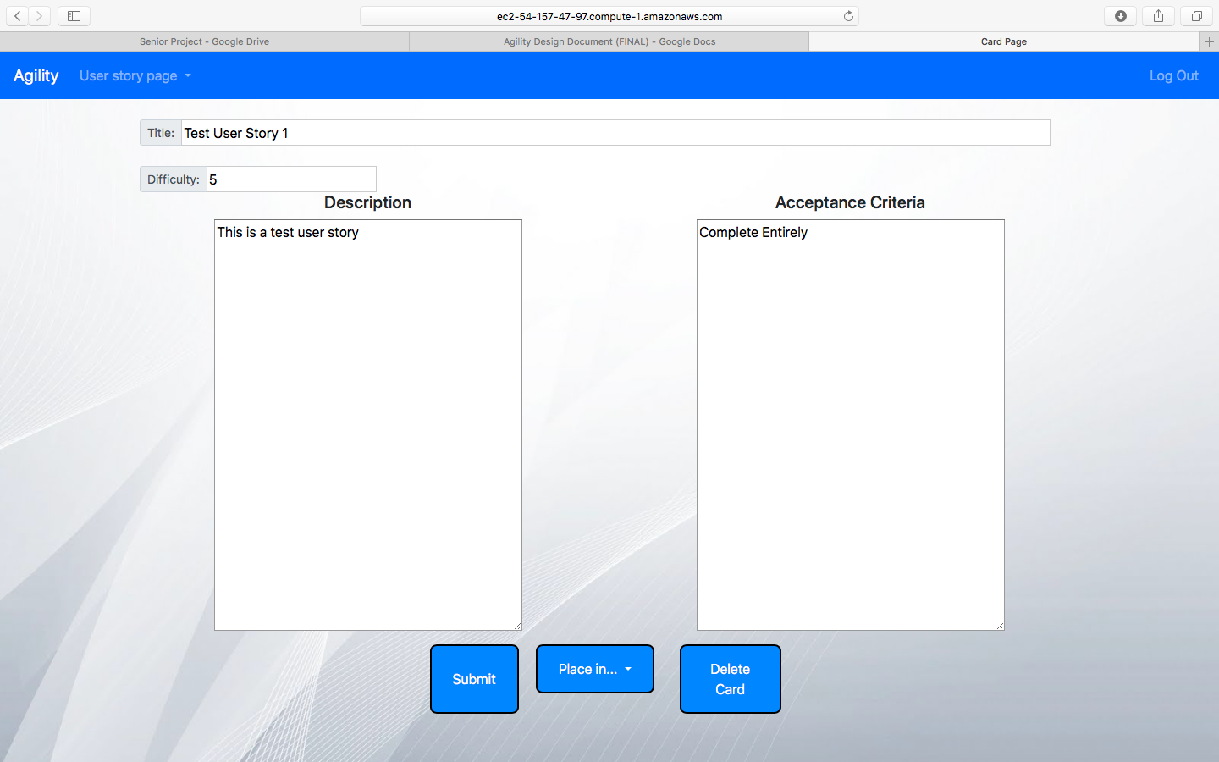

Website endpoints and correlating database tables used by Card Page:

* User_stories table, Project table, Sprint table

Buttons and corresponding tables:

* Submit Button: User_stories table
* Place in Dropdown: User_stories table, Sprint table, Project table
* Delete Card Button: User_stories table, Sprint table, Project table

**Team Page**

The Team Page displays a scrollable list of all the team members for the project. For each member, their team role, name, and email are presented. An “Add Member” button is available for the user, and when clicked navigates to the Add Member Page. For each member in the list, an “Assign Role” dropdown is available, which allows the user to set the role for the team member. The roles are Scrum Master, Product Owner, and Developer. If the role is already set, then instead of the dropdown, a “Remove Role” button is available, which removes the role from the user.

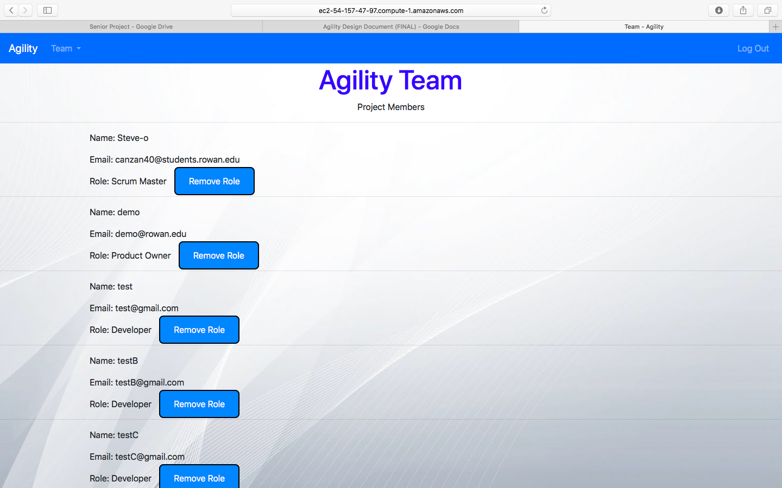

Website endpoints and correlating database tables used by Team Page:

* User table
* User_project table
* Project table
* Team table

Buttons and corresponding tables:

* Role Dropdown/Remove Role: User_project table
* Add Member: Team table, User Table

**Add Member Page**

The Add Member Page displays a header that says “Add Member”, along with text fields for the user to enter the username and email of the member they want to add to the team. Upon clicking the “Enter” button, and if the member information is correct, the member is added to the team and the user is navigated back to the Team Page. If the member information is incorrect, then a message will be displayed stating that the member is not found.

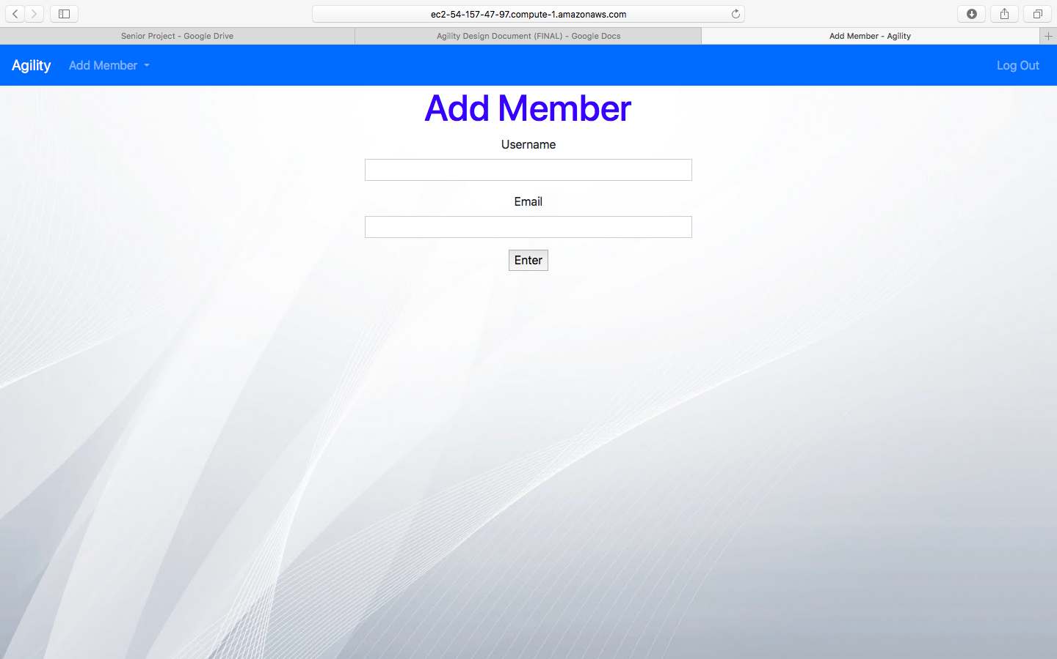

Website endpoints and correlating database tables used by Add Member Page:

* Team table, User table

Buttons and corresponding tables:

* Enter Button: Team table, User table

**EER Diagram**